Teen Vogue

This Is What Happened When I Discovered I Have 22 Siblings

It's not as strange as it sounds.

Kate Dwyer Jan 28, 2016 12:19PM EST
Imagine what would happen if you found out that the man who raised you wasn’t actually your biological father – that you were conceived by a sperm donor, and you had at least 21 half-siblings scattered around the country. Oh, and you’re invited to meet them for an idyllic weekend in Cape Cod. It sounds like the plot of a YA novel, but for Sarah Malley, it’s real life. Last year, after finding a “juicy-looking” envelope in the family safety deposit box, she discovered that she and her twin sister Jenna were conceived with the help of the California CryoBank. The 27-page packet inside contained crucial information about her donor father, including his CryoBank ID number. Curious about his identity, Sarah signed up for the Donor Sibling Registry.
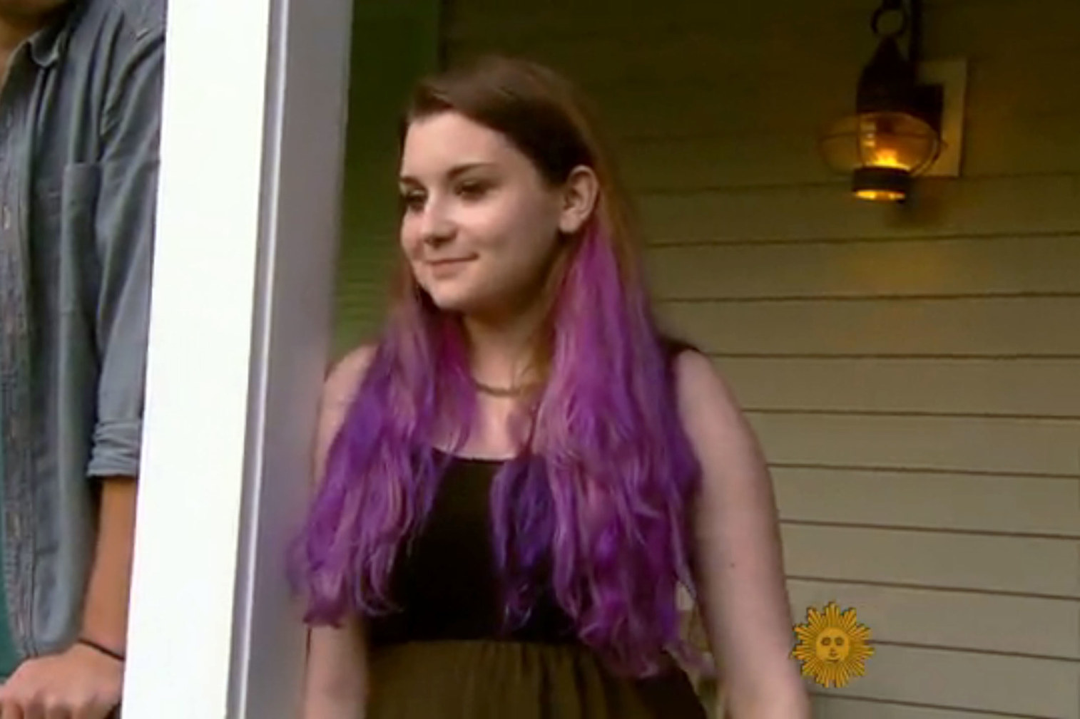
The Donor Sibling Registry (DSR) is an online community for donor-conceived half-siblings, mothers of donor-conceived children, and donors, to connect with one another. It was started in 2000, by Wendy Kramer, the mother of a donor-conceived son who wanted to learn more about his donor dad. “The Donor Sibling Registry was started because of one child’s curiosity,” she tells Teen Vogue. She thought, “maybe Ryan’s not the only curious child out there.” Since then, the registry has matched thousands of children with their half-siblings and donor dads.
On the Registry, Sarah was able to match her father’s donor ID number with a name and a face: Todd Whitehurst, a 49-year-old Google executive. She decided to email him. “I was literally just hoping to get an email back saying ‘cool that you’re alive, have a nice life, let me know if you have medical questions or something,’” she tells Teen Vogue. The next day, she woke up to a detailed message from Todd, who had just returned from a vacation with two of Sarah’s half-siblings, Carey and Gavin. They — along with eight other half-siblings — were registered on the DSR. “I thought I had 10 half-siblings. But Todd gently corrected me, ‘you have 21.’” (Now 22.) Four weeks after contacting Todd, Sarah received an invitation from one of her half-siblings’ mothers, for a meeting in Cape Cod during the upcoming summer. Then, on her 20th birthday, Todd (who then worked at Apple) sent her an iPhone. “I thought to myself, I must be the luckiest donor kid in the whole world.”
The weekend in Cape Cod was the first time Sarah got to meet her donor dad, as well as a handful of her half-siblings. A few days before the big day arrived, she received an email from CBS explaining that they’d be taping the meeting. (The segment ran earlier this month). Sarah had already been nervous about meeting the “family” for the first time, but admits there was added pressure because of the cameras. “I had been thinking, ‘what do you wear when you meet your biological father and six of your half siblings for the first time?’ Then it was like, ‘what do you wear when you meet your biological father and six of your half siblings for the first time, and — oh, yeah — it’s going to be on national TV? Everyone kept asking me why I was so scared. I have four tattoos, I have purple hair, I’m a writing major at a liberal arts school, and literally all these people are math and science people. I was very confident I would be the odd one out.”
But once everyone started to get to know each other, her anxiety melted away. “I forgot that there were cameras surrounding us. And there were a bunch of similarities we started to notice.” She and Todd would make the same jokes at the same times, and she and Carey both had red birthmarks on their legs. “We got along so well right away. I knew right from meeting them; in a lot of cases, you feel like you have to love your family, but this was like hanging out with your friends — oh and by the way they’re related to you.” She and Todd get dinner whenever he’s in town for work, and she and her half-siblings make time for each other whenever they’re in the same city.
Teen Vogue also got a chance to talk to Todd about how his life has changed since kids started reaching out to him. “The richness that it’s added to my life has been dramatic overall. No one wants anything unreasonable from me, and I’ve met a lot of kids at this point. None of them were expecting me to step in and be a dad, or come to every soccer game or do things that a traditional father would do, which given my current professional life wouldn’t be possible.” He encourages other donor dads out there to register on the DSR, because he’s met donor-conceived children frustrated by the fact they that don’t know who their father is. “It’s been an amazing, very rewarding, uniformly positive experience for me, and I would encourage other dads out there to be a lot more open to experiencing all of the goodness that comes along with this.”
Sarah says that her relationship with her half-siblings has also brought her closer to her sister, Jenna. “She’s the only person in the world who knows exactly what I’m going through.” That includes getting to know the half-siblings, whom she’s sure will remain in her life. "It was incredible to meet these people who were so much like me who I had so much in common with. Gavin said it really well — ‘how awesome is this? We just met, and now we’re going to be best friends for life.'"

