Teen reunites with egg donor family for Nashville graduation
Heidi Hall, For The Tennessean6:04 a.m. CDT May 14, 2016
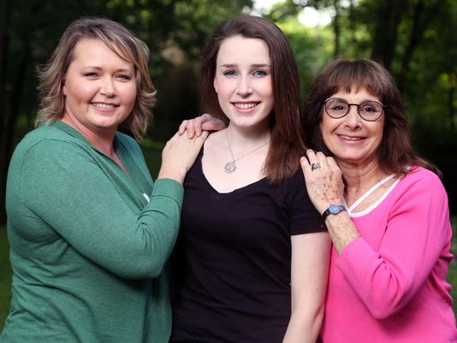Buy Photo
(Photo: Alan Poizner / For The Tennessean)
The two women who gave Brittan Gilmore life will sit beside each other and sob on Saturday, watching their baby put on her Martin Luther King Jr. Academic Magnet cap and gown and collect her diploma.
One of them carried her for 9 months, read her bedtime stories, helped her navigate AP classes and prom dresses and boy drama.
The other has known her only a couple of years — mostly through calls and texts — even though she’s the one who shares Brittan’s nose, her shy smile, her quiet voice.
But the daughter, mother and egg donor consider themselves inextricably linked, at first through biology and today through love. They’re advocates for more transparency around the largely unregulated sperm and egg donor industry and say they want other parents to embrace candor with their donor-conceived kids.
“I just felt like I wanted to know where I came from,” Brittan said. “I have my family, and I love them, but this other person helped create me, too, and I wondered what she was like.”
Eighteen years ago, facing the problem of early menopause, Nashville writer Janet Schreibman and her husband, Jim Gilmore, opted to use egg donation to conceive their daughter. Their anonymous donor: The young wife of a soldier stationed at Fort Campbell, JoLana Talbot, who ultimately would donate 348 eggs over her seven visits to Nashville Fertility Center.
Brittan knew about her unusual beginnings from the age of 7 and, at 16, located her egg donor with the help of Schreibman, an online database called the Donor Sibling Registry and Facebook. They met face-to-face on Katie Couric’s talk show stage in 2014 and granted several media interviews in the weeks that followed.

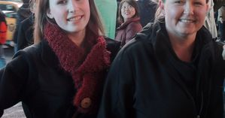
THE TENNESSEAN
Nashville teen finds her egg donor mom

“I’m not here to swoop her kid up,” said Talbot, who is visiting Nashville from Houston for Brittan’s high school graduation.
“Seriously, I think donors could be fearful of that,” Schreibman said. “I’d like to see the industry regulated in a fair way so that, if anonymous donors and their offspring are mutual agreeable, they can find each other.”
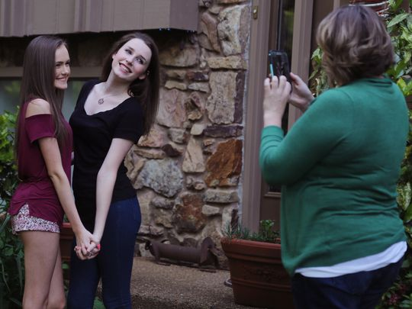Buy Photo
Brittan Gilmore, center, who was conceived with an egg donor, has her picture taken with her half-sister Bry Talbot by Bry's mother and Brittan's egg donor, JoLana Talbot, right. The Talbots are in Nashville to attend Gilmore's graduation. (Photo: Alan Poizner / For The Tennessean)
They also want others to experience the feeling of wholeness that comes from piecing together the entire family — which includes, in this case, at least the two daughters Talbot conceived traditionally after making her egg donations. Brittan also may have countless other half-siblings with no idea she exists, and Talbot, who never lost her attachment to the eggs she left behind in Nashville, would like for them to find her.
“I don’t want to actively seek them out because it’s the parents’ choice to tell them, and I know most don’t,” Talbot said. “But even when I was donating, I was looking at a photo album in the waiting room at the clinic, and I just knew these twins I saw were mine. As soon as I saw Brittan friend-requested me on Facebook, she looked just like my kids.”
There are no regulations limiting the number of children born to one donor or forcing fertility clinics to keep accurate, updated medical records, said Wendy Kramer, who founded the Donor Sibling Registry. Kramer, whose son was conceived through sperm donation, also wants to eliminate anonymous donations.
The registry hit 50,000 people this month.
“We hear stories all the time about random meetings — on a Disney cruise, in the park, at a school function, on vacation, at summer camp,” Kramer said. “Kids and older siblings are meeting up. The industry says statistically, it can’t happen, but it does happen. It’s very important parents are honest with their kids that they are donor-conceived, that they give them the donor number and that they come to our website and register.”
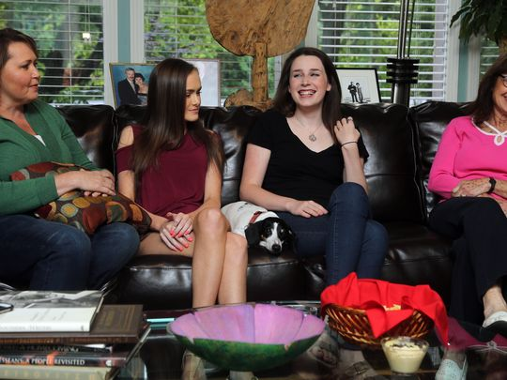Buy Photo
Brittan Gilmore, center right, who was conceived with an egg donor, spends time with egg donor JoLana Talbot, left, half-sister Bry Talbot, center left, and mother Janet Schreibman, right, Tuesday, May 10, 2016. (Photo: Alan Poizner / For The Tennessean)

If parents aren’t honest, she said, it’s becoming more likely their adult children will find out the truth through DNA testing — and the resulting matches with relatives they’ve never heard of. A team of British researchers supported that idea with a paper published in the journal Human Reproduction last month.
Brittan, who heads off to the University of Alabama this fall to study nursing, said she’s grateful for her mother’s support but can’t imagine a time she won’t be in touch with her newfound relations, too. She has come to see Talbot as her “cool aunt.”
“Crazy aunt,” Talbot corrected, and the two shared their quiet laugh as Schreibman chuckled beside them in her living room, their unusual family just as comfortable as it could be.

